

Draw It or Lose It

# **CS 230 Project Software Design Template**

Version 1.0

## Table of Contents

**CS 230 Project Software Design Template**1

**Table of Contents**2

**Document Revision History**2

**Executive Summary**3

**Design Constraints**3

**System Architecture View**3

**Domain Model**3

**Evaluation**3

**Recommendations**5

## Document Revision History

| Version | Date | Author | Comments |
| --- | --- | --- | --- |
| 1.0 | 08/13/2020 | Jeffrey Caldarelli | Executive Summary, Design Constraints, Domain Model, Evaluation and Recommendations |

**Instructions**

Fill in all bracketed information on page one (the cover page), in the Document Revision History table, and below each header. Under each header, remove the bracketed prompt and write your own paragraph response covering the indicated information.

## Executive Summary

This particular design problem involves a timed guessing game called Draw it or Lose it, in which teams try to guess what is being drawn, or sketched. There are 4 rounds, each timed at 1 minute each. The drawings will take 30 seconds to complete. This client is asking to produce game attributes such as multi-team play and unique player IDs. The client is also asking for one instance of the drawing game, for which we will produce specific identifiers for players, teams, and games.

## Design Constraints

* The game must be runnable on many diverse platforms
* We must use the client’s library of images
* We are limited to only use programming languages that run efficiently in a web-based environment to write the application
* We must consider the different hardware requirements of all different platforms

## System Architecture View

Please note: There is nothing required here for these projects, but this section serves as a reminder that describing the system and subsystem architecture present in the application, including physical components or tiers, may be required for other projects. A logical topology of the communication and storage aspects is also necessary to understand the overall architecture and should be provided.

## Domain Model

Provided below is a UML diagram depicts object-oriented design principles, such as the inheritance of the game, team, and player classes which are in the Entity class. These three classes have the “is a” relationship with the entity class. The classes team and player are of a “has a” relation with one another. Another object-orientated principle expressed in this diagram is how the entity class protects the program’s data by limiting access to any public methods in the program. This protects the privacy of players’ information and is called encapsulation.

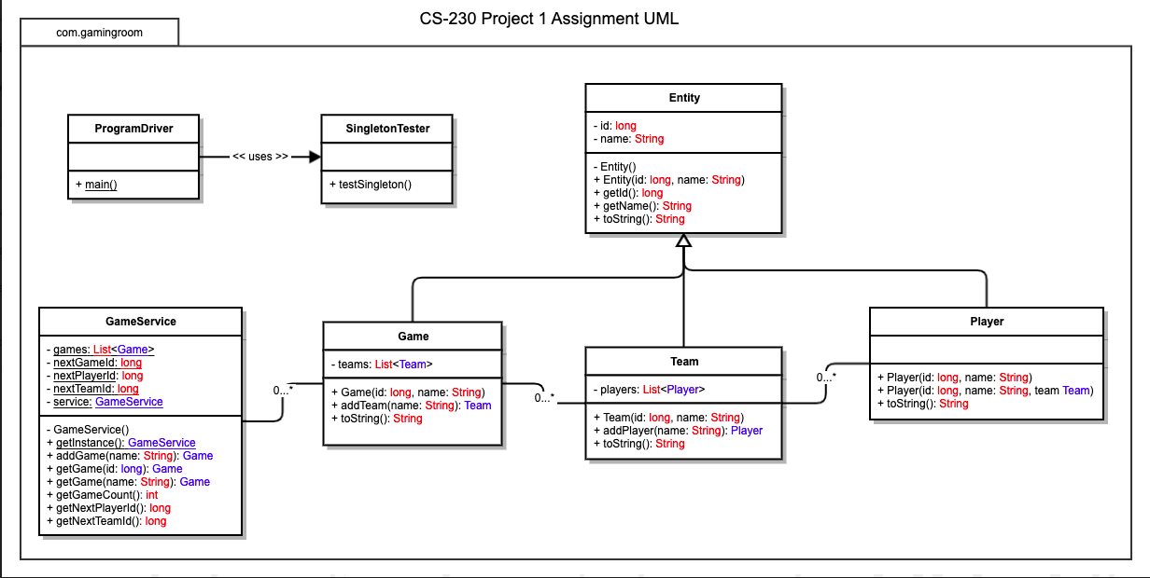

## Evaluation

Using your experience to evaluate the characteristics, advantages, and weaknesses of each operating platform (Linux, Mac, and Windows) as well as mobile devices, consider the requirements outlined below and articulate your findings for each. As you complete the table, keep in mind your client’s requirements and look at the situation holistically, as it all has to work together.

In each cell, remove the bracketed prompt and write your own paragraph response covering the indicated information.

| **Development Requirements** | **Mac** | **Linux** | **Windows** | **Mobile Devices** |
| --- | --- | --- | --- | --- |
| **Server Side** | Costly. Great GUI. Flexible workstation for ease of access and configuration. Supports LDAP. Utilizes a command shell to simplify server configuration/ accessibility. Contains file and user access controls. | Inexpensive. Platform can be hard to navigate. As with Macs, Linux has a command shell, and has user and file access controls. Decision required regarding vender support and distribution version. | Expensive. Easy to use platform. Wide variety of Windows software options. Also has user and file access controls. LDAP support is limited with Windows. | Cost effective. Android, iOS, WP.  Specifications vary from user to user. IOS and Android developer tools are required. |
| **Client Side** | Average support time required. Good skill is needed. More expensive than competitors. Mac operating systems support browsers such as Firefox, Chrome, and Safari. | The support time of this OS, Linux, is very high. Master level operation skills required. Linux Operating system supports Chrome and Firefox browsers. | Low support and time required to support Windows OS users. Comparable to cost of Mac. Browsers such as Chrome, Firefox, and Edge are supported with Windows. | Maximum support time for mobile device users. Android supports Chrome and Firefox while IOS supports Chrome, Firefox, and Safari. |
| **Development Tools** | Common languages and IDEs used on Mac include JavaScript, CSS, Python, HTML, as well as others. There are also tools like libraries, Visual Studio, Eclipse and so on | Languages utilized are Ruby on Rails, Java, Python, CSS, JavaScript, HTML, and others. Tools include Visual Studio, Github, Repl.it, and command prompt. | Languages include Ruby on Rails, Java, C++, Python, C#, JavaScript, HTML, and others.  Tools include Visual Studio, Eclipse, Repl.it, command prompt. | Primary languages include Python, Java, CSS, Javascript, C++, among others. Tools include Github, command prompt, and Visual Studio. |

## Recommendations

1. **Operating Platform**:

The recommended operating platform for allowing the expansion of the Draw it or Lose it program is Windows OS. I recommend this because of the increased software availability IDE’s to work with. Furthermore, Windows requires minimal cost and expertise to utilize, as compared with other platforms.

1. **Operating Systems Architectures**:

With the purchase of an activation code, Windows provides access to system-based resources, services to Windows based apps that show a Graphical User Interface, web services, messaging, and more. It also offers a wide variety of software packages and programing options. Command prompt power shell is used for Windows server configuration. Lastly, Windows provides developers the ability to utilize a variety of programming languages.

1. **Storage Management**:

The storage system on Windows 10 provides for simple creation of files as well as storage placement of larger projects. This platform is equipped with a storage sense feature, allowing for increased ease of managing files on your hard drive as well as controlling the amount of storage space the files utilize. Another storage management feature enables the user to have more control over where to save apps, allowing for easier access. As with other devices, cloud storage is an additional option.

1. **Memory Management**:

A library or database will need to be created during the development of Draw it or Lose it, in order to manage the images associated with the game. Windows memory allocation provides for simple storage of images apart from the default image folder, which allows the user to maintain the working project in a single, secure location. Windows provides both virtual and physical address space up to 4 gigabytes of memory.

1. **Distributed Systems and Networks**:

As the client would like for Draw it or Lose it to communicate between various platforms, we must consider IDE’s that allow cross-platform creation and communication. One example, Develop 4, can run on any devices. Following the creation of the gaming software, the gaming file can then be exported into Android, web, IOS and other alternatives which helps limit dependencies of platforms by allowing cross-play. The company still needs to ensure their servers have the strength and support necessary to handle the large amount of players, as well as a backup power option in case of loss of power.

1. **Security**:

The Windows platform comes equipped with security protection software, including features which scan the system for security threats, viruses, and malware. These scanning security features are also updated periodically, as threats to the system are constantly adapting. However, alternative sources are recommended for optimal security of user data. Windows also provides user account control settings to further secure data traveling to or from the system. Another security feature is the requirement of administrative acceptance of any modifications applied to the program. Also, VPN service capabilities boost the protection of client information and history.